**PRACTICA PARA EL TEST ORAL**

**PART 1:** Questions from the teacher (2 minutes)

¿De dónde eres?

¿Cómo es tu país? ¿Dónde está? ¿Qué hay?

¿Tienes hermanos? ¿Qué hacen? ¿Dónde viven?

¿Cuántos años tienes?

¿Cómo eres? ¿Cómo es físicamente tu padre/madre/hermano…?

¿Cuántas lenguas hablas?

¿Cuáles son tus aficiones?

¿Dónde vives? ¿Con quién?

¿Qué estudias?

….

¿Cómo es tu rutina diaria? ¿El fin de semana?

¿A qué hora te levantas / desayunas/comes/cenas/ te acuestas…?

¿Cuál es tu momento preferido de la semana?

¿Normalmente qué desayunas/ comes/cenas?

¿Te gusta vivir en Manchester? ¿Por qué?

¿Qué (no) te gusta hacer en tu tiempo libre / el fin de semana…?

¿Te gusta la música? ¿Qué tipo de música?

¿Qué vas a hacer / harás mañana este verano / este fin de semana… (futuro)

¿Qué has hecho hoy/esta mañana/ esta tarde /esta semana/este mes..?(Pretérito perfecto)

¿Qué has desayunado/ comido?

¿Has visitado alguna vez…?

¿Has estado en España alguna vez? ¿Dónde?

¿Qué hiciste ayer/ anteayer/ el verano pasado / el fin de semana pasado…?

¿Qué desayunaste / comiste / cenaste ayer?

¿Cuándo fue la última vez que viajaste?¿Te gustó?

¿Cuál es tu plato favorito? ¿Cuáles son los ingredientes?

¿Te gusta/n….? ¿Cómo lo/la/los/las comes?

**PART 2:** Describing, giving an opinion, comparing and talking about an image which presents prompts around the various contexts practiced throughout the year. The images will be offered by the teacher and will include people, everyday objects and places. (2 minutes)

1. Explicar qué te gusta y qué no te gusta y por qué en relación a la comida

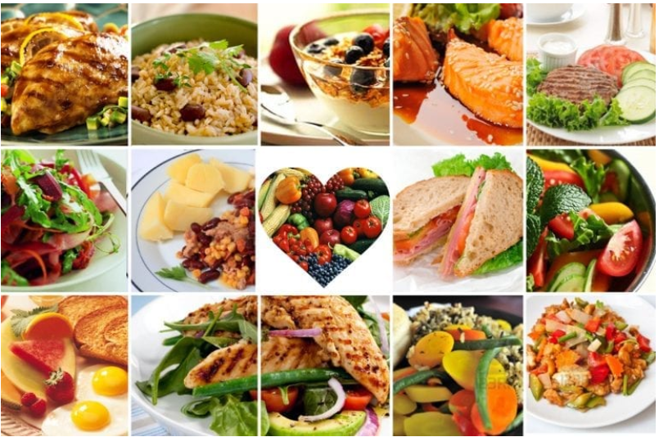

* Explica qué comidas te gustan en general, cuáles son tus favoritas y por qué.
* ¿Qué ingredientes llevan?
* ¿Dónde las comes normalmente? ¿En casa o en el restaurante?
* ¿Cuándo fue la última vez que comiste tus comidas favoritas?
* ¿Has probado alguna comida diferente este año

B) Describir una fotografía de un lugar.

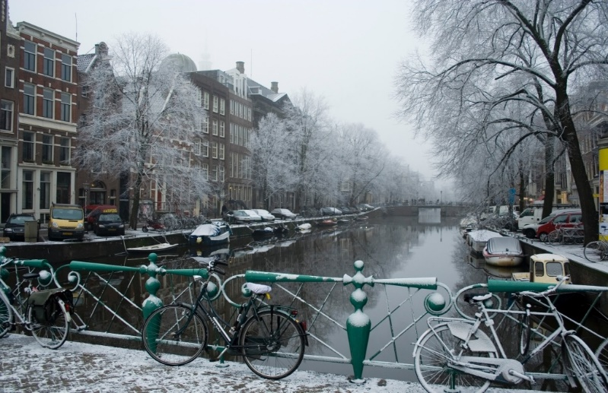

* Cómo es y qué hay en el lugar
* El tiempo
* Comparación con otro lugar
* Actividades que puedes hacer allí.
* ¿Has estado ahí alguna vez? ¿Cuándo fuiste y con quién? ¿Qué actividades hiciste?

1. Describir una persona.

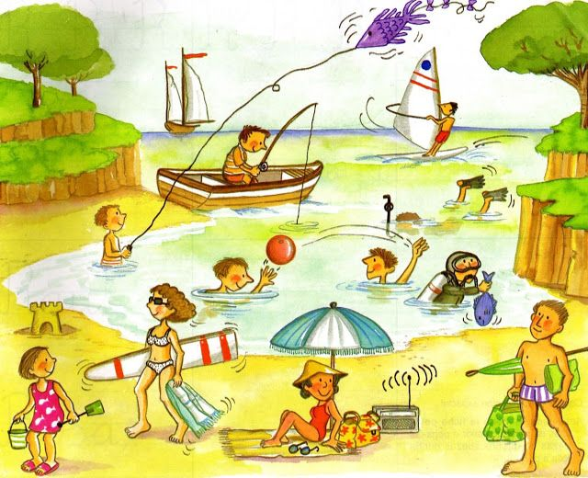

* Relación familiar
* Descripción (apariencia física, edad, profesión, ropa, cómo se sienten, sus gustos…)
* Dónde está cada persona en la imagen
* Comparación de esta persona con otra de tu familia o de la imagen.
* Describe qué hiciste tú en tus vacaciones el año pasado y algo que has hecho este año
* Planes que tienes tú o esta persona para el futuro

**LEAP oral assessment descriptors for Beginner, Introductory and Pre-Intermediate levels**

|  |  |  |  |  |  |  |  |  |
| --- | --- | --- | --- | --- | --- | --- | --- | --- |
| *Equally weighted* |  | **Less than 40%/Fail** | **40%+** | **50%+** | **60%+** | **70%+** | **80%+** | 90%+ |
| **Range of lexis and sophistication of expression** | % | The speaker cannot even use the most basic constructions. | Speaker is unable to use anything other than very basic constructions and very simple words and phrases. | Speaker tends to only use simple constructions with a very limited range of words/phrases. | Speaker can use a good range of words, phrases and structures for this level. | Though most constructions are simple and or common, the speaker varies the structures used. The range of words and phrases is high for this level. | Although most constructions are common and/or simple, the speaker is able to vary construction with ease and use a very wide range of words and phrases for this level. | Speaker uses an impressive range of vocabulary for this level. Language is expressed with a good level of sophistication. |
| **Accuracy** | % | Speech characterised by very many errors in basic grammar and vocabulary. | Speech characterised by many errors in basic grammar and vocabulary. | Speech characterised by some errors in basic grammar and vocabulary. | Speech exhibits some inaccuracies in grammar and word use, but most basic language is sound. | Speech exhibits only a few minor inaccuracies in grammar and word use, but these tend to be associated with more difficult constructions. | Speech exhibits hardly any inaccuracies in grammar and word use, even with more difficult constructions. | Speech exhibits no inaccuracies in neither grammar nor word use. |
| **Fluency**  **Phonological clarity and accent** | % | The speaker cannot achieve any kind of discourse fluency and/or manage the interaction.  A very strong L1 accent causes strain for the listener. All words are mispronounced. | The speaker makes frequent pauses and hesitations even when the topic is simple.  A strong L1 accent causes strain for the listener. Most words are mispronounced. | The speaker can communicate effectively and reasonably fluently some of the time.  Accent may be strong but this does not impede understanding. Quite a few mispronunciations occur. | The speaker can communicate effectively and reasonably fluently most of the time. Rate of production and quality of smoothness are adequate but tend to deteriorate when the topic is complex.  Accent may be marked in places but this does not impede understanding. Some mispronunciations may occur. | The speaker communicates effectively and fluently most of the time. Rate of production and quality of smoothness are generally good for this level.  Speech is characterised by an acceptable L1 accent. Most words are pronounced correctly. Natural intonation and rhythm are evident. | The speaker communicates very effectively and fluently most of the time. Rate of production and quality of smoothness are generally very good.  Speech is characterised by a very acceptable L1 accent. Nearly all words are pronounced correctly. Natural intonation and rhythm are evident. | The speaker communicates effectively and fluently throughout. Rate of production and quality of smoothness are impressive. There is little evidence of an L1 accent. All words are pronounced correctly. Speaker utilises natural intonation and rhythm throughout. |
| **Task fulfillment and communicative quality**  **(includes: turn taking, facial expressions, gestures and eye contact)** | % | Task is unfulfilled. Little evidence of preparation and there is no coherent structure. Speaker displays no spontaneity.  Communicative style is unengaging, cold and unfriendly. | Task fulfillment is largely inadequate. Evidence of poor preparation and little evidence of coherent structure. Speaker lacks spontaneity. Communicative style is unengaging and rather unfriendly. | Task fulfillment is adequate but incomplete. The task is structured but could have been more thoroughly prepared. Speaker displays some spontaneity. Communicative quality is adequate. | Task fulfilled to a satisfactory standard. Well-structured, displaying both preparation and sufficient spontaneity. An engaging communicative style. | Task fulfilled to a very satisfactory standard. Well-structured, displaying both good preparation and good spontaneity. A very engaging communicative style. | Task fulfilled to much more than a satisfactory standard. Well-structured, displaying both thorough preparation and excellent spontaneity. A thoroughly engaging communicative style. | Task fulfilled to an impressive standard. Faultlessly structured, displaying both thoughtful preparation and excellent spontaneity throughout. |
| **Final mark** | **%** |  |  |  |  |  |  |  |

**Comments:**